CmpE 110 PARTS LIST:

Wrist band, 2 oscilloscope probes, red and black banana cables (for power), breadboard and wire kit

Resistance values (1/4 watts, 2 of each otherwise noted below):

1, 10, 100, 150, 220, 270, 330, 390, 470, 560, 680, 750 and 820ohms.
1 (8 of them), 1.5, 2.2, 2.7, 3.3, 3.9, 4.7, 5.6, 6.8, 7.5, 8.2Kohms
10 (8 of them), 15, 22, 27, 33, 39, 47, 56, 68, 75, 82Kohms
100 (8 of them), 150, 220, 270, 330, 390, 470, 560, 680, 750, 820Kohms and 1Mohm

Capacitor values (2 of each otherwise noted below):

1, 10, 100pF
1, 10, 100nF
100, 200, 400, 600, 800µF

Inductor values (2 of each otherwise noted below):

1, 10, 100µH
1mH

Diodes (4 of each otherwise noted below):

1N4001 rectifying diode
3.3V and 5V Zener diode
Red LED (2 of each)

NPN transistors (2 of each):

2N3904

TTL gates (2 of each):

SN7404 (inverter), SN7405 (open-collector inverter)

CMOS gates (5 of each):

CD4069 (inverter), CD4011 (2-input NAND), CD4001 (2-input NOR)

Operational amplifiers (4 of each):

LM324 (with Vcc = +/- 5V)

CmpE 110 LAB 1 Dr. A. Bindal

FIRST-ORDER PASSIVE CIRCUITS

Part 1: RC Circuits

(a) Using the resistor values, R = 1 KΩ, 10 KΩ, 100KΩ and 1MΩ calculate the capacitor values for a time constant value of = 1 µs in each case.

(b) Use each R-C combinations found in part (a) in the circuit below and measure the rise time and the fall time at the output, vout. You need to connect pulse generator that changes between 0 and 5V at the input of the circuit and observe the circuit response at the output terminal using the oscilloscope. Note that the rise time is measured from 20% of the output voltage to 80% of the output voltage; similarly, the fall time is measured from 80% of the output voltage to 20% of the output voltage.

(c) Use each R-C combinations found in part (a) in the circuit below and measure the time constant using your oscilloscope’s cursors.

Show the calculated and measured rise and fall times and time constants in an Excel table and explain the error between the measured and calculated values. For un-measurable cases, show the results of you scope screen and explain why measurements could not be made.

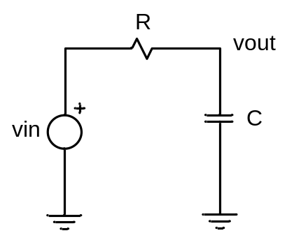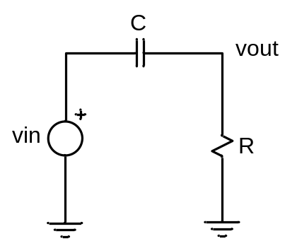

Part 2: RL Circuits

(a) Using the resistor values, R = 1 KΩ, 10 KΩ, 100KΩ and 1MΩ calculate the inductor values for a time constant value of = 1ns in each case.

(b) Use each R-L combinations found in part (a) in the circuit below and measure the rise time and the fall time at the output, vout. In this case, you still need to use a pulse generator that changes between 0 and 5V at the input of the circuit and observe the circuit response at the output terminal using the oscilloscope.

(c) Use each R-L combinations found in part (a) in the circuit below and measure the time constant using your oscilloscope’s cursors.

Show the calculated and measured rise and fall times and time constants in an Excel table and explain the error between the measured and calculated values. For un-measurable cases, show the results of you scope screen and explain why measurements could not be made.

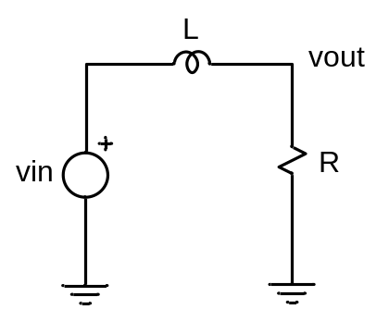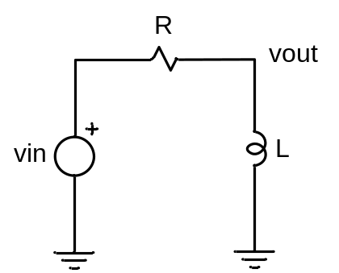

CmpE 110 LAB 2 Dr. A. Bindal

SECOND-ORDER PASSIVE CIRCUITS

A series RLC circuit is given below. The output voltage is observed across a capacitor using an oscilloscope while input voltage changes between 0 V and 5 V using a pulse generator.
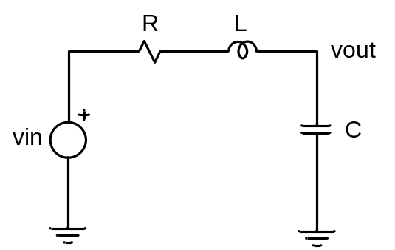

Considering the output voltage of this network has 2 roots of its characteristic equation.

s1 = 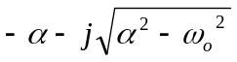
s2 = 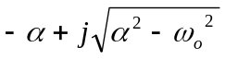

where,

- If C = 100pF is used in the circuit above, calculate L such that the oscillation angular frequency, 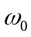, is 10⁷rad/sec.

- Use the values of C = 100pF and the value of L determined in part (a), construct separate RLC circuits with R = 0Ω, 1Ω, 10Ω, 100Ω, 1KΩ, 10KΩ, and compute the real and imaginary parts of s1 and s2 in each case. Tabulate your results in Excel table.

(c) Apply the pulse generator at vin that changes between 0 and 5V to each RLC circuit in part (b) and measure the rise and fall times at vout using your oscilloscope’s cursors. Make sure to adjust your pulse width large enough such that the output voltage settles at a certain value before taking measurements. Tabulate your results in Excel table.

- Apply the pulse generator at vin that changes between 0 and 5V and measure the time constant (when applicable) at vout for each RLC circuit in part (b) using your oscilloscope’s cursors. Tabulate your results in Excel table.

- Apply the pulse generator at vin that changes between 0 and 5V and measure the free oscillation frequency,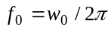, (when applicable) at vout for each RLC circuit in part (b) using your oscilloscope’s cursors. Tabulate your results in Excel table.

It is critical to explain your results and the error between the measured and calculated values in your report. For un-measurable cases, show the results of you scope screen and explain why measurements could not be made.

CmpE 110 LAB 3 Dr. A. Bindal

DIODE CIRCUITS

Part 1: Simple diode circuits

Construct the diode circuit below with VCC = 5V and 1N4001 rectifying diode. Measure the output voltage at vout, which should be around 0.7V. Allow only 10mA through the circuit. Re-compute the value of the resistor RD such that ID would be 1mA and 100mA. Does the output voltage change in each case? Record your values in Excel table.
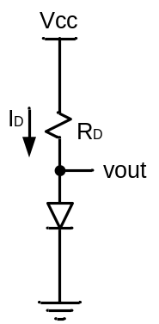

Now, replace the supply voltage, VCC, with an AC voltage source whose maximum amplitude changes between +10V and -10V with a frequency of 100Hz as shown in the figure below. Determine R such that the AC current becomes less than 10mA. Record the output waveform.
Now attach a parallel capacitor, C, to the output resistor as shown in the figure below. Adjust the value of the capacitor such that the output ripple voltage becomes less that 100mV.

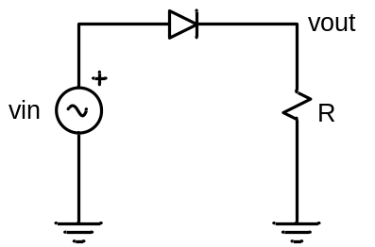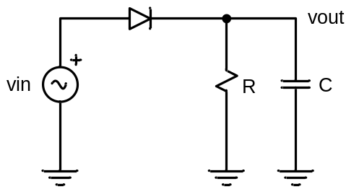

Part 2: Bridge rectifier

Construct the diode circuit below with 1N4001 rectifying diodes and an AC voltage source whose maximum amplitude changes between +10V and -10V with a frequency of 100Hz as shown in the figure below. Use 100Ω, 1KΩ and 10KΩ, and measure the output voltage at vout in each case. Adjust the value of the capacitor such that the output ripple voltage becomes less that 100mV.

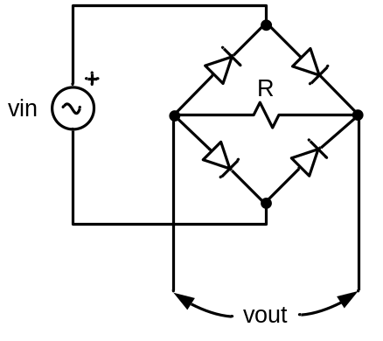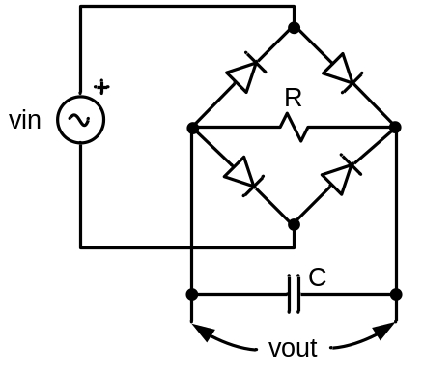

Part 3: Zener diode circuit

Construct the diode circuit below with VCC = 10V and 3.3V and 5V Zener diode. Determine RZ such that the current through the circuit does not exceed the rated power level of the Zener diode. Measure the output voltage at vout and tabulate your results.

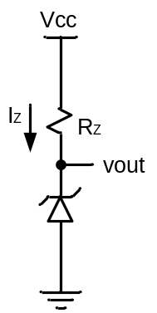

Part 4: Light Emitting Diode (LED) circuit

Construct the diode circuit below with VCC = 10V and LED. Determine RL such that the current through the circuit does not exceed the rated current level of the LED for correct brightness. Measure the output voltage at vout and tabulate your results.

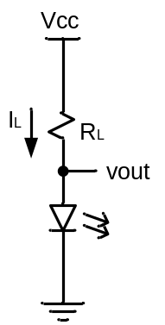

CmpE 110 LAB4 Dr. Ahmet Bindal

Part 1: Simple bipolar circuits

Construct the bipolar circuit below using the npn transistor, 2N3904.
Attach IN = 5V as shown below and determine Rb and Rc to saturate this transistor (IBSAT >> ICSAT / β).
The transistor in saturation should produce roughly VBE = 0.8V and VCE = 0.2V.

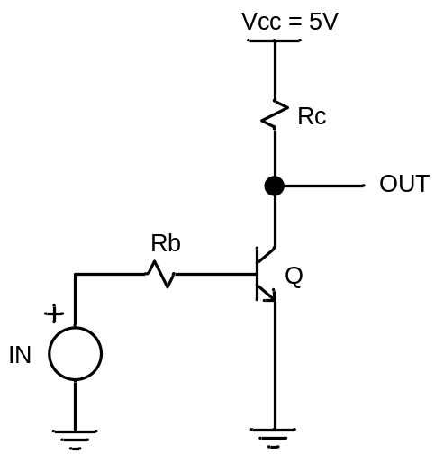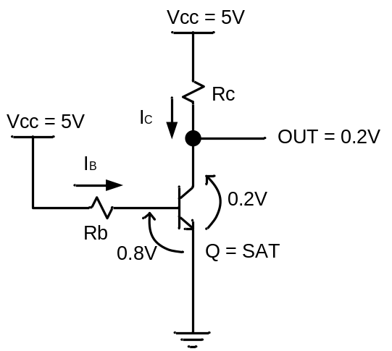

Part 2: Inverter rise and fall propagation delays and times as a function of output load

Connect the output of CD4069 inverter below to multiple identical inverters to measure the rise and fall propagation delays, and the rise and fall times as a function of fan-out (the number of identical inverters at the output).

Use a pulse generator that changes between 0 and 5V. Start your experiments by connecting no load (no inverter) at the output and go up to 20 inverters, incrementing 4 inverters at a time as your load. Record propagation rise and fall delays, rise and fall times in each case; tabulate and plot your results as a function of fan-out. Explain your results.

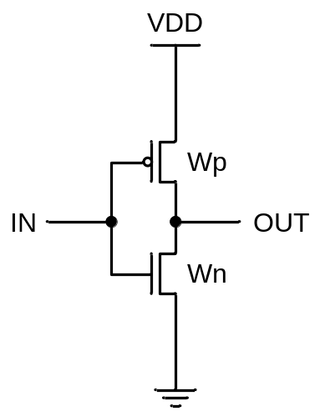

Part 3: 2-input NAND gate rise and fall delays and times as a function of output load

Connect the output of CD4011 2-input NAND gate to multiple identical NAND gates (connect A and B inputs together when you use the NAND gate as a load) to measure the rise and fall propagation delays, and the rise and fall times as a function of fan-out.

Again use a pulse generator that changes between 0 and 5V. Start your experiments by connecting no load and go up to 20 NAND gates, incrementing 4 NAND gates at a time as your load. Record propagation rise and fall delays, rise and fall times in each case; tabulate and plot your results as a function of fan-out. Explain your results.

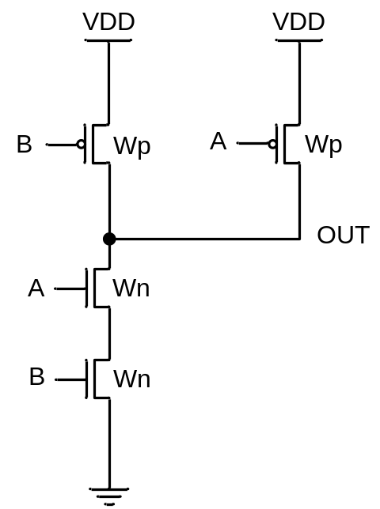

Part 4: 2-input NOR gate rise and fall delays and times as a function of output load

Connect the output of CD4001 2-input NOR gate to multiple identical NOR gates (just like in part 2, connect A and B inputs together when you use the NOR gate as a load) to measure the rise and fall propagation delays, and the rise and fall times as a function of fan-out.

Again use a pulse generator that changes between 0 and 5V. Start your experiments by connecting no load and go up to 20 NOR gates, incrementing 4 NOR gate at a time as your load. Record propagation rise and fall delays, rise and fall times in each case; tabulate and plot your results as a function of fan-out. Explain your results.

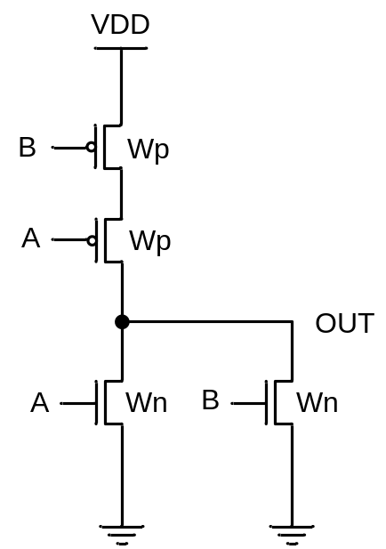

CmpE 110 LAB5 Dr. Ahmet Bindal

Part 1: TTL driving CMOS

Construct the circuit below such that a TTL inverter drives a CMOS inverter with a bipolar circuit. Use SN7404 TTL inverter and CD4069 CMOS inverter. Consider the values of VIH, VIL, VOH, VOL, IIH, IIL, IOH, IOL of both gates from data sheets to determine the value of Rb and Rc such that the bipolar transistor changes its state between cut-off and saturation regions.

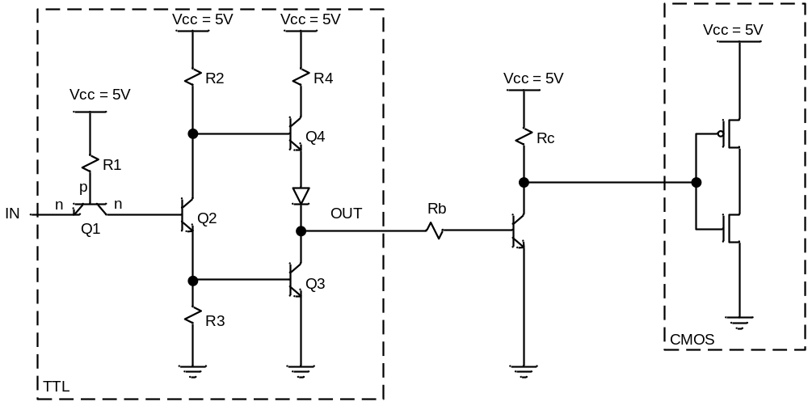

Part 2: CMOS driving TTL

Construct the circuit below such that a CMOS inverter drives a TTL inverter with a bipolar circuit. Use CD4069 CMOS inverter and SN7404 TTL inverter. Consider the values of VIH, VIL, VOH, VOL, IIH, IIL, IOH, IOL of both gates from data sheets to determine the value of Rb and Rc such that the bipolar transistor changes its state between cut-off and saturation regions.

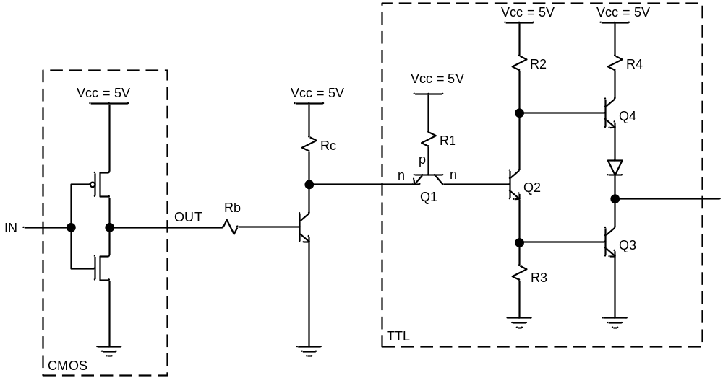

Part 3: TTL inverter with open collector

Connect the open-collector TTL inverter, SN7405, shown below to drive an LED. Determine RL such that the bias current through LED provides satisfactory luminescence according to the manufacturer’s recommendations.

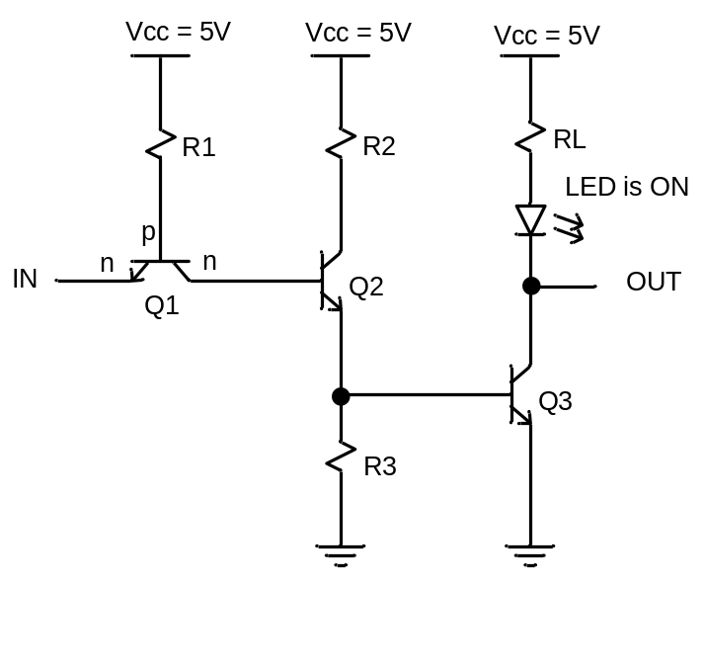

CmpE 110 LAB6 Dr. Ahmet Bindal

Part1: Design a voltage sensor amplifier with an amplification of -10

Design the following operational amplifier circuit such that the amplification is -10. Assume the input voltage is sinusoidal at 1KHz and its value is 0.1V peak to peak. Use LM324 operational amplifier with +5V and -5V power supplies.
After measuring the voltage gain, explain the inconsistencies between the experiment and the theory.

Increase the frequency to 10KHz, 100KHz and 1MHz and measure the gain in each case. Record the drop in amplification and explain the reason behind this drop.

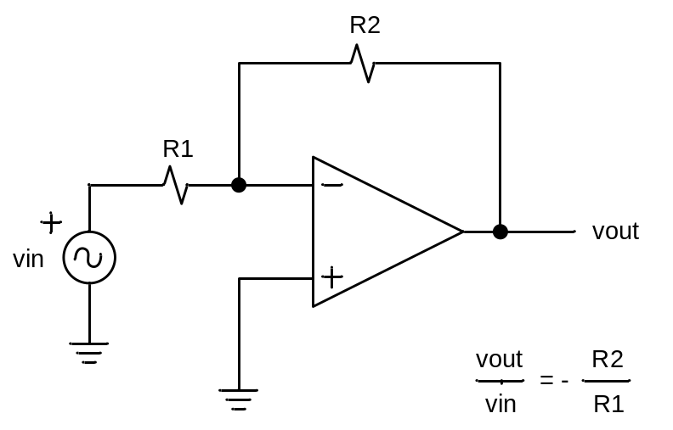

Swap the connections at the input of the operational amplifier (input goes to “+” terminal and ground goes to “-“ terminal).
Would you get vout / vin = R2 / R1 = +10? If not, explain the reason.

Part 2: Design voltage sensor amplifier with an amplification of +10

Design the following operational amplifier circuit such that the amplification is +10. Assume the input voltage is sinusoidal at 1KHz and its value is 0.1V peak to peak. Use LM324 operational amplifier with +5V and -5V power supplies.
After measuring the voltage gain, explain the inconsistencies between the experiment and the theory.

Increase the frequency to 10KHz, 100KHz and 1MHz and measure the gain in each case. Record the drop in amplification and explain the reason behind this drop.
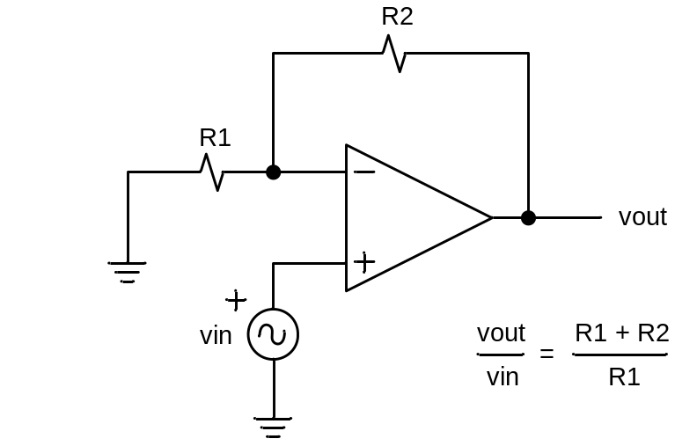

Swap the connections at the input of the operational amplifier (input goes to “-” terminal and R1-R2 connection ground goes to “+“ terminal).
Would you get vout / vin = (R1 + R2) / R1 = -10? If not, explain the reason.

Part 3: Design input/output isolation circuit with unity gain

Measure the output voltage when you change the input peak-to-peak voltage 0.5V, 1V and 2V oscillating at 1KHz. Explain the inconsistencies between the experiment and the theory.
Increase the frequency to 10KHz, 100KHz and 1MHz and measure the gain in each case. Record each value and explain the reason behind the drop in unity gain.

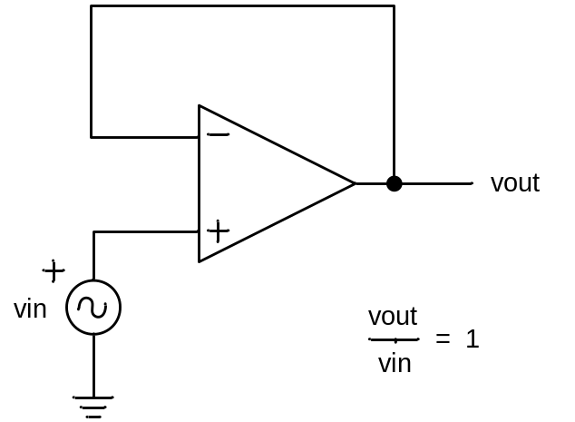

Swap the connections at the input of the operational amplifier (input goes to “-” terminal and the feedback loop goes to “+“ terminal).
Would you get vout / vin = -1? If not, explain the reason.

Part 4: Design a voltage sensor amplifier with signal and reference inputs

Apply vsig (mimicking a sensor) and vref as sinusoidal inputs at 1KHz. How can you achieve vout = - (vsig – vref)? Show it theoretically and experimentally by determining the resistor values. Determine the resistor values such that you get vout = -A (vsig – vref) where the amplification factor, A, is equal to 10?
Find RA and RB to generate vref = 0.75vsig, vref = 0.5vsig and vref = 0.25vsig using the operational amplifier circuit below and repeat the experiment for A = 1 and A = 10. Tabulate your findings in each case.
Use maximum 1V peak to peak voltage for vsig.

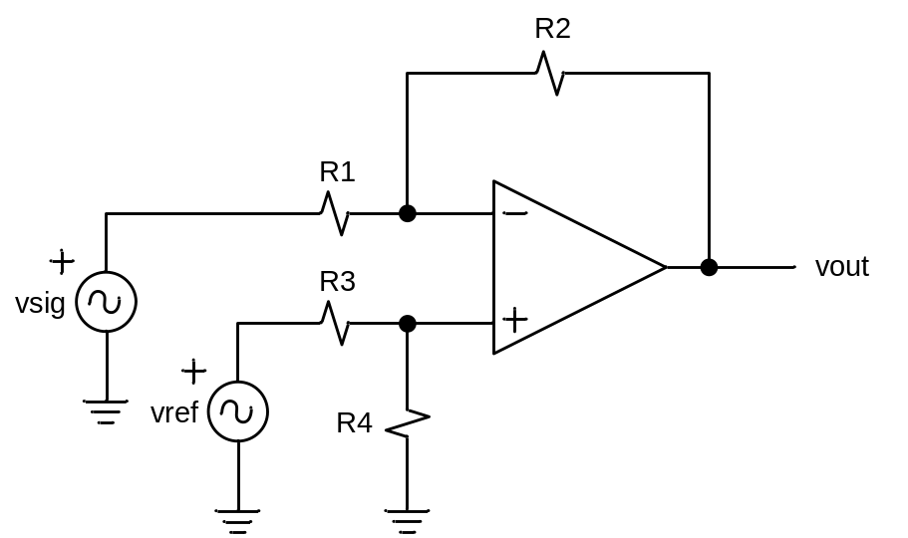

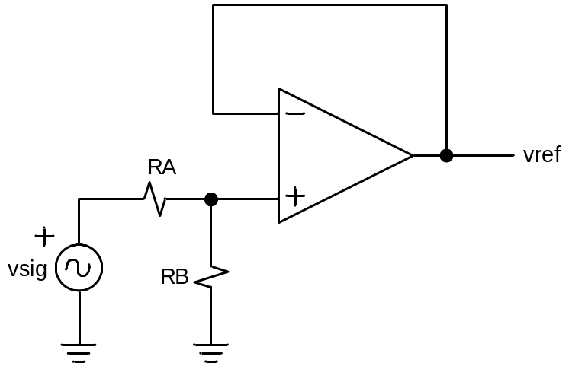

Part 5: Design a summation amplifier with 2 sensor inputs

Apply vin1 = 1V peak-to-peak, and generate vin2 = 0.25vin1, vin2 = 0.5vin1 and vin2 = 0.75vin1 from vin1 by adjusting RA and RB in the circuit shown on the previous page. Record each output value. Explain the inconsistencies between the experiment and the theory.

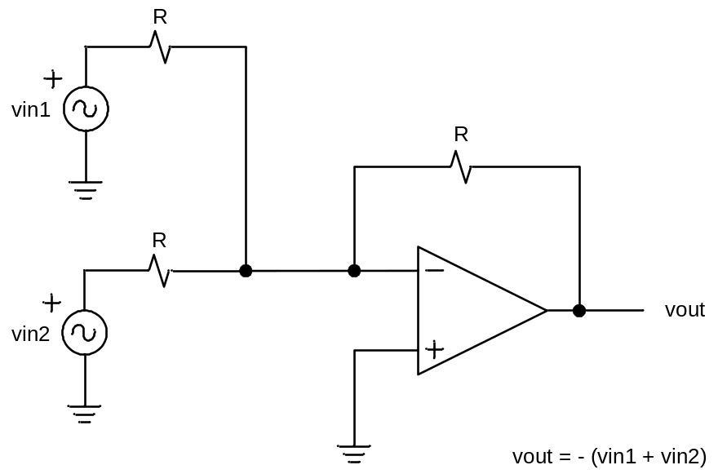

CmpE 110 LAB7 Dr. Ahmet Bindal

Part 1: Design a 2-bit flash Analog-to-Digital Converter (ADC)

Using the circuit schematic below, apply 5V to each operational amplifier as the power source and to the vref terminal. Assume R = 10Kohms.

Increase vsig amplitude from 0V to 5V by 0.2V increments and record the output values in each case. How does out [7:0] relate to your vsig input? Measure the error between the input voltage, vsig, and out [7:0].

Refer to CmpE 124 notes and implement a decoder circuit using Karnaugh maps to obtain DOut [2:0], a 3-bit digital representation of out [7:0]. Use LEDs at DOut [1:0] to determine the correctness of your decoder.

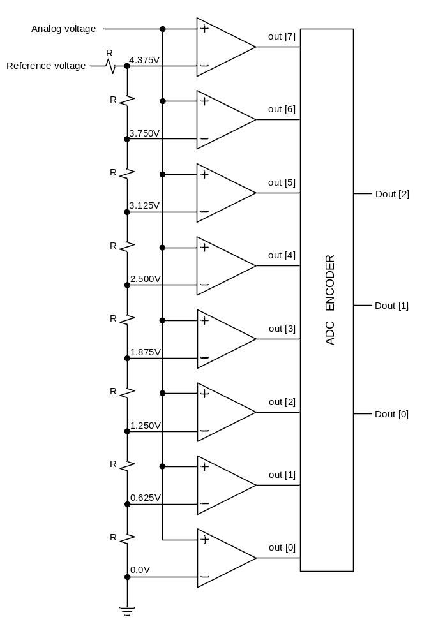

Part 2: Design a 3-bit Digital-to-Analog Converter (DAC)

Using the circuit schematic below, apply +Vcc = +10V and –Vcc = -10V to the operational amplifier. Assume R = 10Kohms (if this value does not work, try increasing the resistance value).

Apply LOGIC 0 = 0V and LOGIC 1 = 5V to MSB, MID and LSB inputs as shown in the truth table. Measure the output voltage, vout, and the error between the expected output voltage and the experimental output value in each case. Explain the reason of the error.

How do you select LOGIC 1 level such that the maximum output voltage at vout is 4.375V for MSB = LOGIC 1, MID = LOGIC 1, LSB = LOGIC 1?

